

The Small Office Network

* Supervised by:
* Engineer Islam Edrees
* Team members:
* Kirollos Magdy Eskander Zaky
* Mahmoud Abdelaty Hassan Ahmed
* Mahmoud Elsayed Mohamed
* Mina Samy Sobhy
* Mostafa Saied Ahmed Omran
* Yousif Anwar Abdelrahman Mohamed

Track Name:Infrastructure & Cybersecurity

Group Name:CCNA (GIZ1_ISS2_M1d)

Technical Training Company:Global Knowledge

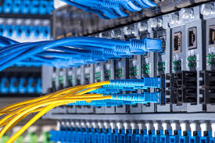



Introduction

**"Building a Seamless and Efficient Internal Network: Tailored Solutions for All Your Business Needs"**

Small businesses face increasing challenges in managing their operations efficiently and providing a connected and integrated work environment we offer innovative solutions for designing and implementing custom internal networks that meet the unique needs of each company.

We believe that every company is unique, and therefore, its internal network should be as well.

**What we offer:**

* **Comprehensive Assessment:** We conduct a thorough evaluation of your company's needs in terms of size, structure, and applications used to determine the optimal solution for your internal network.
* **Efficient Design:** We design internal networks that meet your current and future requirements, with a focus on efficiency and security.
* **Professional Implementation:** We implement your project to the highest quality standards, using the latest technologies and equipment.
* **Ongoing Technical Support:** We provide you with the necessary technical support to ensure your network operates smoothly and efficiently.

**Why choose us?**

* **Extensive Experience:** We have extensive experience in designing and implementing internal networks for small businesses.
* **Specialized Team:** Our team comprises a select group of networking experts, ensuring you receive the best solutions.
* **Comprehensive Solutions:** We offer comprehensive solutions that cover all aspects of your internal network, from infrastructure to applications.
* **Competitive Pricing:** We offer competitive pricing and high quality.

**Technologies we use:**

* **LAN (Local Area Network):** For connecting devices within a single location.
* **WAN (Wide Area Network):** For connecting multiple company locations.
* **CAN (Controller Area Network):** Used to control industrial devices.
* **MAN (Metropolitan Area Network):** Covers a larger geographical area than LAN but smaller than WAN.
* **Multi-layer switch (core switch):** For organizing data traffic and improving performance.
* **EtherChannel:** For increasing data transfer speeds and providing redundancy.
* **VoIP (Voice over Internet Protocol):** For providing voice communication services over the network.

**Ether Channel Group (Port Aggregation Protocol - PAgP)**

* **Definition:** A technology that allows multiple physical Ethernet links to be bundled together to create a single logical link. This increases bandwidth and provides redundancy in case of a link failure.
* **Benefits:**
  + Increased bandwidth
  + Redundancy
  + Load balancing
  + Failover

**Spanning Tree Protocol (STP)**

* **Definition:** A protocol that prevents network loops by disabling redundant links in a network topology.
* **Benefits:**
  + Prevents network loops
  + Improves network stability
  + Provides redundancy

**VLAN (Virtual Local Area Network)**

* **Definition:** A logical grouping of devices on a physical network that allows them to communicate as if they were on the same physical network, regardless of their physical location.
* **Benefits:**
  + Improved security
  + Increased flexibility
  + Reduced broadcast traffic
  + Improved network performance

For the network design, we relied on LAN and WAN technologies, utilizing a multi-layer switch (core switch) for efficient data traffic management. We also implemented EtherChannel technology to enhance data transfer speeds and provide redundancy in case of cable failures. The network is equipped with internet service, a router, high-speed cables, and VoIP support for voice communication services. Additionally, the network is configured with a large number of computers.

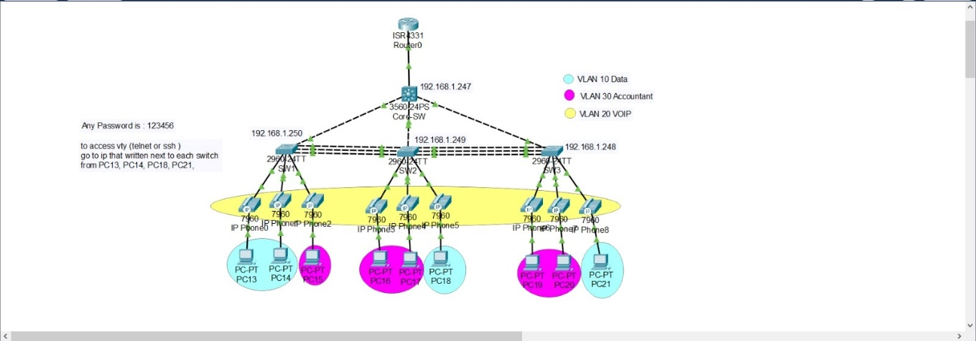

We used same Routers , Switchs , pcs and telephones over ip :-

**A switch** is a network device that connects multiple devices together and forwards data packets based on their MAC addresses. It operates at the Data Link layer of the OSI model.

**Key functions of a switch:**

* **Filtering:** Switches examine the MAC addresses of incoming data packets and forward them only to the intended recipient. This helps reduce network traffic and improve performance.
* **Bridging:** Switches create a bridge between different network segments, allowing devices in different segments to communicate with each other.
* **Segmentation:** Switches can divide a network into smaller segments, improving network security and reducing the impact of network failures.

**Types of Network Switches**

Switches are essential components of modern networks, connecting multiple devices and forwarding data packets efficiently. There are several types of switches available, each with its own characteristics and use cases:

**1. Layer 2 Switches**

* **Most common type:** Operates at the Data Link layer of the OSI model.
* **MAC address-based forwarding:** Forwards data packets based on their MAC addresses, ensuring they reach the intended recipient.
* **VLAN support:** Can create virtual LANs (VLANs) to segment networks and improve security.
* **Examples:** Cisco Catalyst 2960, 3560, and 3650 series.

**2. Layer 3 Switches**

* **Combines switching and routing:** Operates at both the Data Link and Network layers of the OSI model.
* **IP address-based forwarding:** Can route data packets based on their IP addresses, making them suitable for larger networks and inter-network communication.
* **Routing protocols:** Supports routing protocols like RIP, OSPF, and BGP.
* **Examples:** Cisco Catalyst 6500, 9000, and Nexus series.

**3. Managed Switches**

* **Centralized control:** Can be configured and managed remotely using network management protocols like SNMP.
* **Advanced features:** Offer advanced features like QoS, port mirroring, and security features.
* **Suitable for larger networks:** Ideal for complex networks that require centralized management and control.

**4. Unmanaged Switches**

* **Plug-and-play:** Require minimal configuration and are easy to set up.
* **Limited features:** Offer fewer features compared to managed switches.
* **Suitable for small networks:** Suitable for small networks with basic requirements.

**5. Modular Switches**

* **Scalable:** Can be expanded by adding additional modules, such as line cards or power supplies.
* **High-performance:** Designed for high-performance and demanding network environments.
* **Suitable for data centers and large enterprises:** Commonly used in data centers and large enterprises.

**6. Stackable Switches**

* **Multiple units as a single device:** Multiple units can be stacked together to form a single logical device.
* **Simplified management:** Provides centralized management and control for multiple switches.
* **Suitable for medium-sized networks:** Suitable for medium-sized networks that require scalability and centralized management.

**The choice of switch model depends on various factors, including network size, complexity, performance requirements, and budget .**

**Why did we choose the Cisco Catalyst 2960-24TT switch for our project?**

**The Cisco Catalyst 2960-24TT is a popular choice for many small to medium-sized network projects due to several key advantages :-**

* **Balanced performance and price:** It offers excellent performance and scalability while remaining budget-friendly, making it an attractive option for projects with limited resources.
* **Ease of use and management:** The switch features a user-friendly interface, simplifying configuration and management tasks. It also supports standard network management protocols like SNMP, enabling easy network monitoring and administration.
* **Advanced features:** Despite being an entry-level switch, it offers a wide range of advanced features, including:
  + VLANs: Create virtual LANs to segment traffic and enhance security.
  + QoS: Manage quality of service and prioritize different types of traffic.
  + Security: Provides a suite of security features to protect the network from threats.
* **Key benefits of the Cisco Catalyst 2960-24TT:**
  + Reliability and performance: Designed for high performance and reliability in fast-paced network environments.
  + High port density: Offers 24 10/100/1000 Mbps copper ports, making it ideal for covering large areas.
  + Scalability: Can be easily expanded by adding additional modules to increase port count or add new features.
  + Technical support: Backed by extensive technical support from Cisco, ensuring you get the help you need when facing any issues.
  + Compatibility: Compatible with a wide range of devices and software, making it easy to integrate into any network environment.

**In summary, the Cisco Catalyst 2960-24TT is an excellent choice for projects requiring a reliable, high-performing, and easy-to-use switch, all at a reasonable price.**

**Would you like to know more about specific features or have other questions about this switch or networking in general?**

**Here are some additional points that could be included:**

* **Specific use cases:** Mention specific scenarios where this switch would be particularly useful, such as small offices, schools, or branch offices.
* **Comparison to other models:** Briefly compare the 2960-24TT to other similar switches on the market, highlighting its unique advantages.
* **Future-proofing:** Discuss how the switch can be upgraded or expanded to meet future network needs.

**By incorporating these additional points, you can create an even more comprehensive and informative response.**

## Difference between Access Switches and Core Switches

### Access Switches

* **Purpose:** Connect end devices like computers, phones, and printers to the network.
* **Location:** Typically at the edge of the network, close to the devices they serve.
* **Features:**
  + Usually have a large number of unmanaged or lightly managed ports.
  + Primarily used to create and assign VLANs.
  + May have basic QoS features.
* **Performance:** Generally lower performance than core switches, as they are designed for lower traffic.

### Core Switches

* **Purpose:** Form the backbone of the network, connecting access switches together and providing connectivity between different parts of the network.
* **Location:** At the center of the network, where high-density traffic is routed.
* **Features:**
  + Fewer ports, but typically high-speed and multi-layered.
  + Support advanced routing protocols like OSPF and BGP.
  + Provide advanced QoS features for efficient traffic management.
  + May have advanced security features like ACLs.
* **Performance:** Offer very high performance and can handle large amounts of traffic.

**In summary, access switches are the gateways for devices to the network, while core switches are the backbone that connects these gateways together.**

## What is a VLAN and its benefits?

A **VLAN (Virtual Local Area Network)** is a logical division of a physical network into multiple separate networks. Each VLAN operates independently, as if it were a separate network.

**Benefits of VLANs:**

* **Security:** Increases network security by isolating traffic between different segments, preventing unauthorized users from accessing sensitive data.
* **Performance:** Reduces unnecessary broadcast traffic, improving network performance.
* **Management:** Simplifies network management by grouping devices with similar functions into separate VLANs.
* **Scalability:** Allows for flexible network expansion by adding new VLANs without changing the physical infrastructure.
* **Segmentation:** Enables network segmentation based on departments, functions, or users.

**The Configuration code that we used at switches of this project :-**

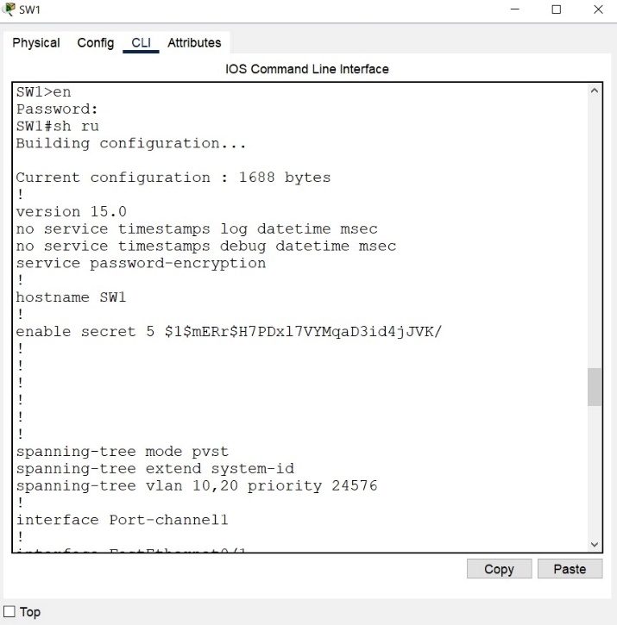- SW-1 runner config-Code:

no service timestamps log datetime msec

no service timestamps debug datetime msec

service password-encryption

hostname SW1

enable secret 5 $1$mERr$H7PDxl7VYMqaD3id4jJVK/

spanning-tree mode pvst

spanning-tree extend system-id

spanning-tree vlan 10,20 priority 24576

interface Port-channel1

interface FastEthernet0/1

switchport mode trunk

interface FastEthernet0/2

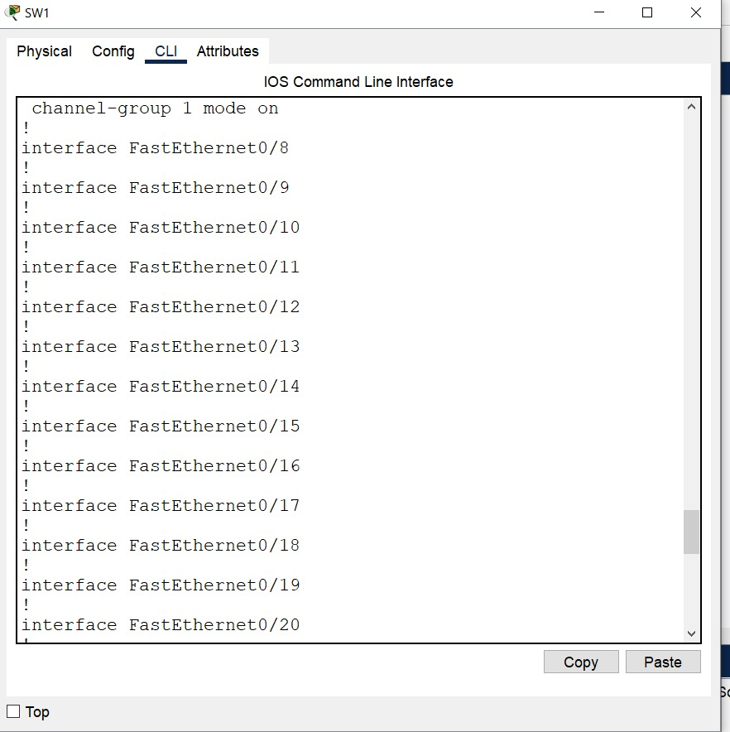 switchport access vlan 10

switchport voice vlan 20

interface FastEthernet0/3

switchport access vlan 10

switchport voice vlan 20

interface FastEthernet0/4

switchport access vlan 30

switchport mode access

switchport voice vlan 20

interface FastEthernet0/5

channel-group 1 mode on

interface FastEthernet0/6

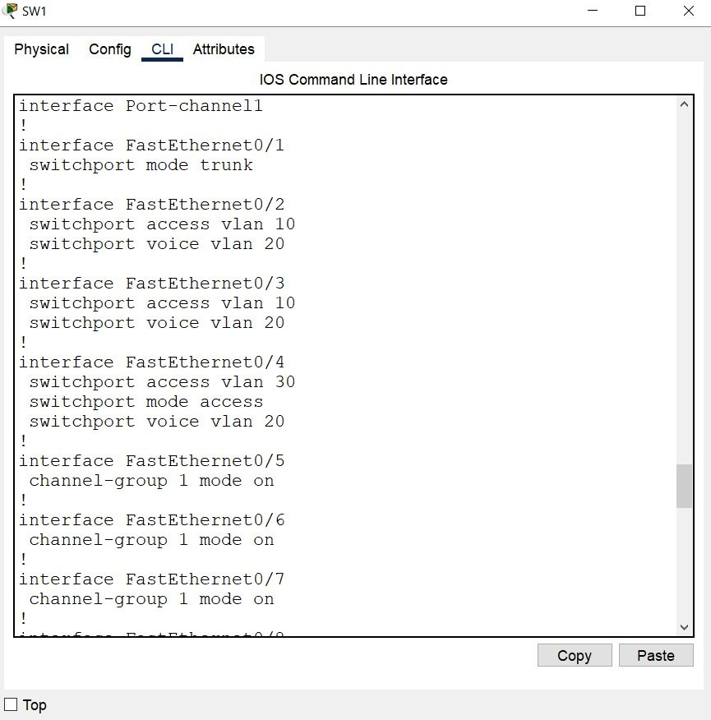 channel-group 1 mode on

interface FastEthernet0/7

channel-group 1 mode on

interface FastEthernet0/8

interface FastEthernet0/9

interface FastEthernet0/10

interface FastEthernet0/11

interface FastEthernet0/12

interface FastEthernet0/13

interface FastEthernet0/14

interface FastEthernet0/15

interface FastEthernet0/16

interface FastEthernet0/17

interface FastEthernet0/18

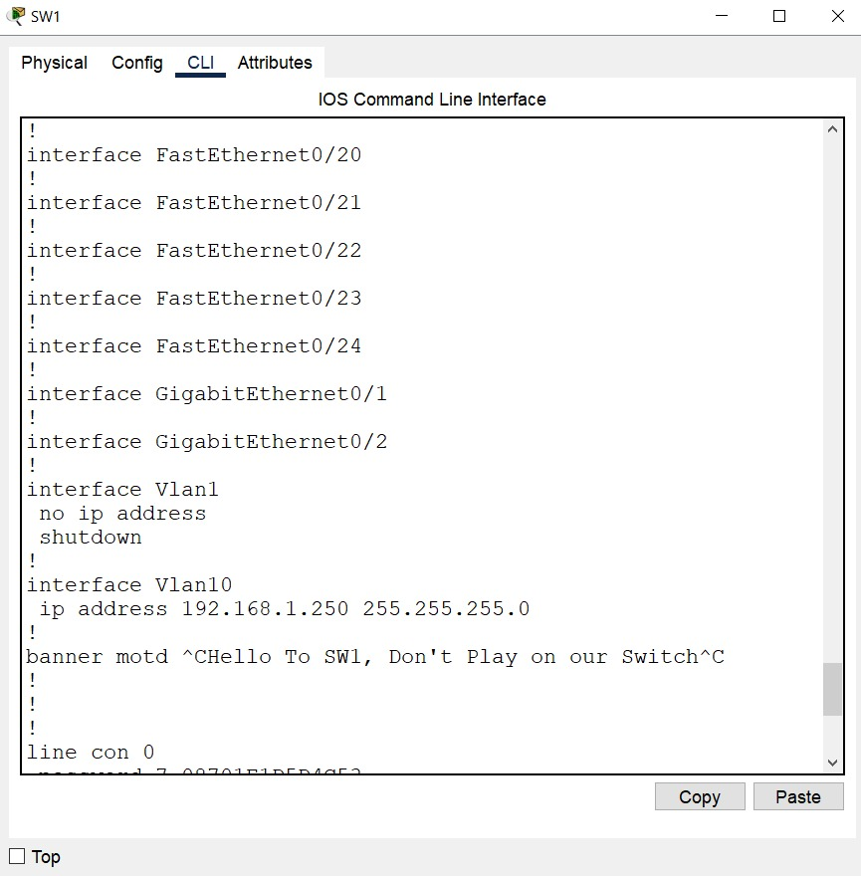interface FastEthernet0/19

interface FastEthernet0/20

interface FastEthernet0/21

interface FastEthernet0/22

interface FastEthernet0/23

interface FastEthernet0/24

interface GigabitEthernet0/1

interface GigabitEthernet0/2

interface Vlan1

no ip address

shutdown

interface Vlan10

ip address 192.168.1.250 255.255.255.0

banner motd "Hello To SW1, Don't Play on our Switch"

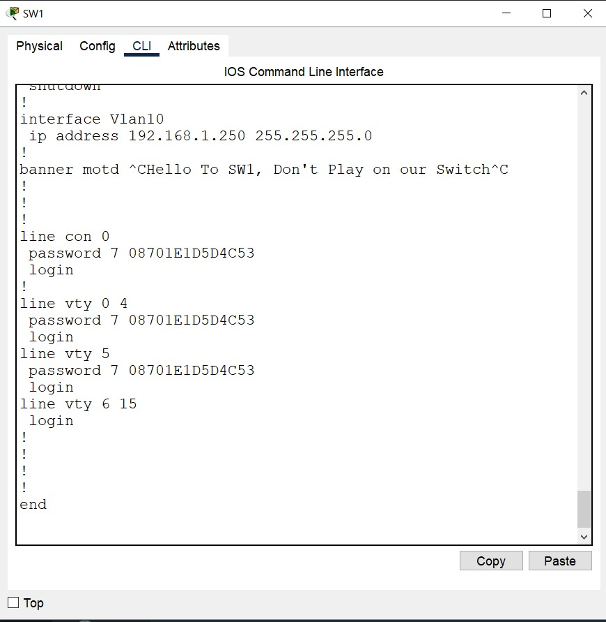line con 0

password 7 08701E1D5D4C53

login

line vty 0 4

password 7 08701E1D5D4C53

login

line vty 5

password 7 08701E1D5D4C53

login

line vty 6 15

login

end

-SW-2 Config-Cod :

no service timestamps log datetime msec

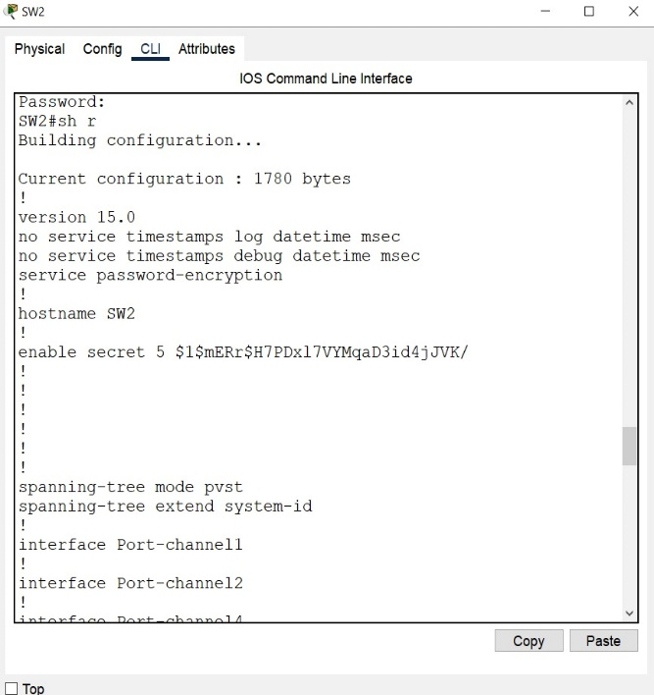no service timestamps debug datetime msec

service password-encryption

hostname SW2

enable secret 5 $1$mERr$H7PDxl7VYMqaD3id4jJVK/

spanning-tree mode pvst

spanning-tree extend system-id

interface Port-channel1

interface Port-channel2

interface Port-channel4

interface FastEthernet0/1

switchport mode trunk

interface FastEthernet0/2

switchport access vlan 30

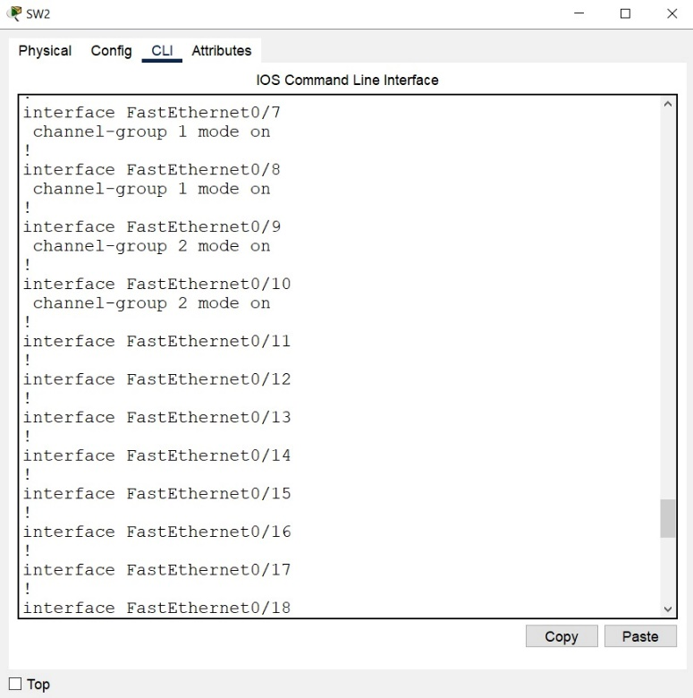 switchport mode access

switchport voice vlan 20

interface FastEthernet0/3

switchport access vlan 30

switchport mode access

switchport voice vlan 20

interface FastEthernet0/4

switchport access vlan 10

switchport mode access

switchport voice vlan 20

interface FastEthernet0/5

channel-group 1 mode on

interface FastEthernet0/6

channel-group 2 mode on

interface FastEthernet0/7

channel-group 1 mode on

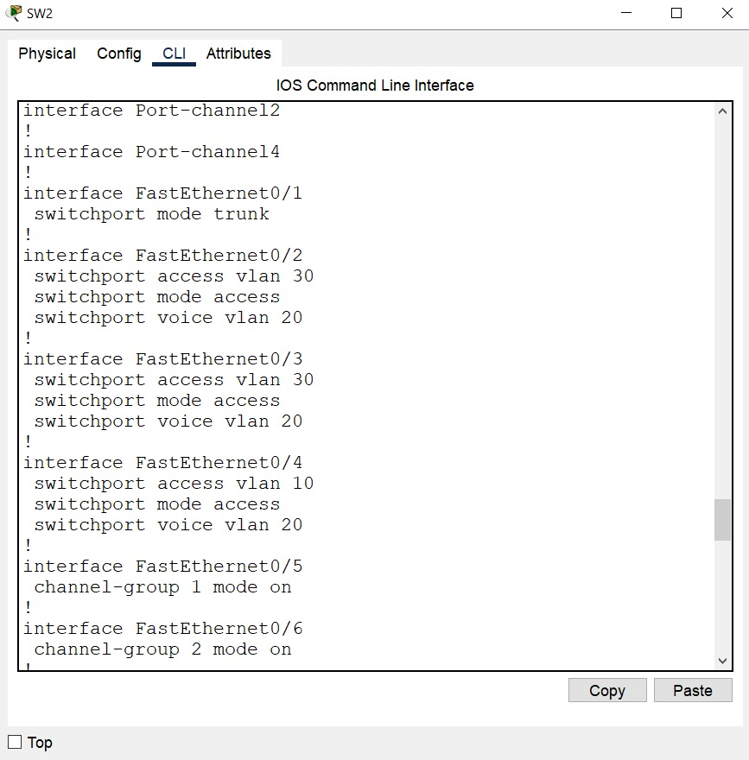interface FastEthernet0/8

channel-group 1 mode on

interface FastEthernet0/9

channel-group 2 mode on

interface FastEthernet0/10

channel-group 2 mode on

interface FastEthernet0/11

interface FastEthernet0/12

interface FastEthernet0/13

interface FastEthernet0/14

interface FastEthernet0/15

interface FastEthernet0/16

interface FastEthernet0/17

interface FastEthernet0/18

interface FastEthernet0/19

interface FastEthernet0/20

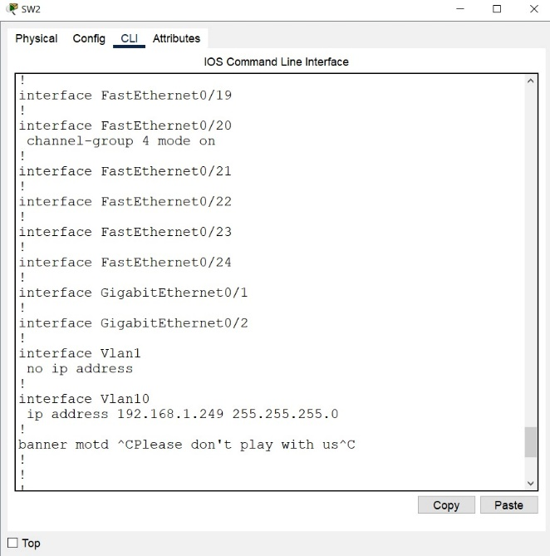 channel-group 4 mode on

interface FastEthernet0/21

interface FastEthernet0/22

interface FastEthernet0/23

interface FastEthernet0/24

interface GigabitEthernet0/1

interface GigabitEthernet0/2

interface Vlan1

no ip address

interface Vlan10

ip address 192.168.1.249 255.255.255.0

banner motd "Please don't play with us"

line con 0

password 7 08701E1D5D4C53

login

line vty 0 4

password 7 08701E1D5D4C53

login

line vty 5 15

login

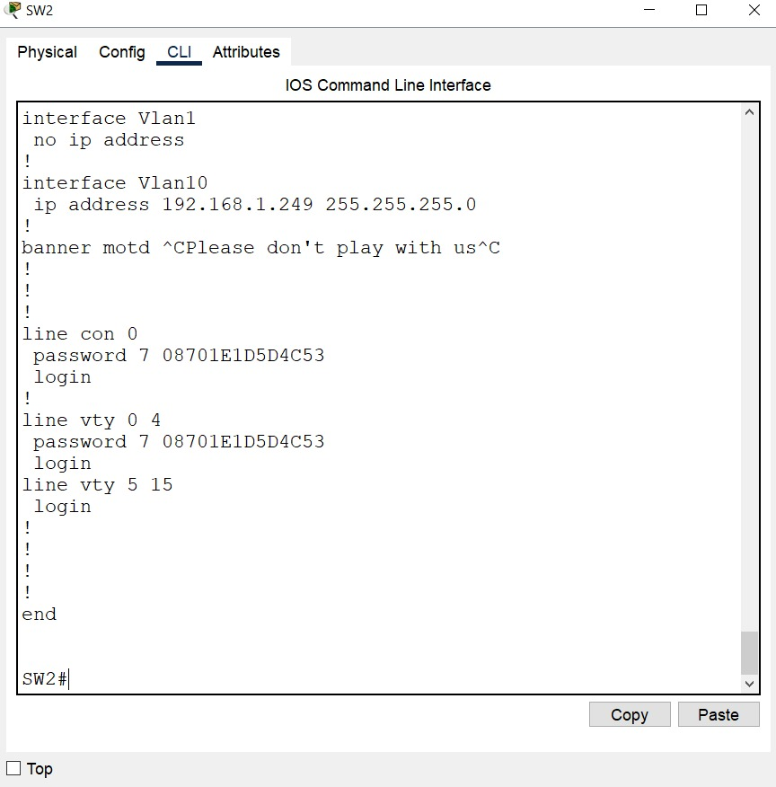end

-SW-3 Config-Code :

no service timestamps log datetime msec

no service timestamps debug datetime msec

service password-encryption

hostname SW3

enable secret 5 $1$mERr$H7PDxl7VYMqaD3id4jJVK/

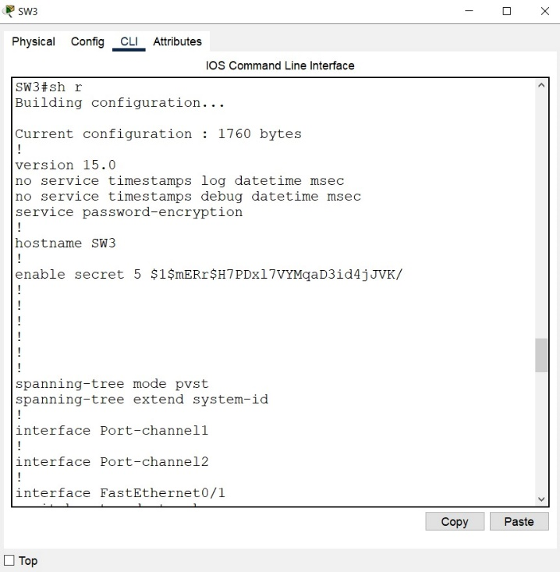spanning-tree mode pvst

spanning-tree extend system-id

interface Port-channel1

interface Port-channel2

interface FastEthernet0/1

switchport mode trunk

interface FastEthernet0/2

switchport access vlan 30

switchport mode access

switchport voice vlan 20

interface FastEthernet0/3

switchport access vlan 30

switchport mode access

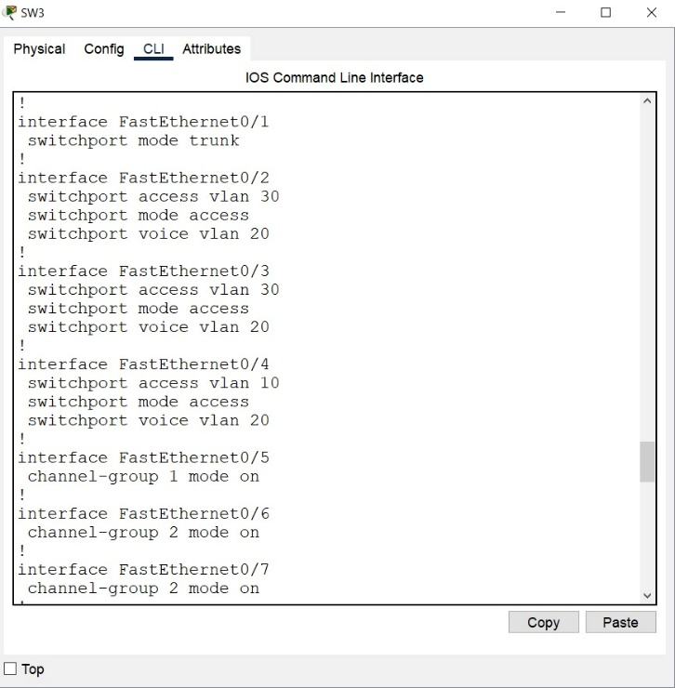 switchport voice vlan 20

interface FastEthernet0/4

switchport access vlan 10

switchport mode access

switchport voice vlan 20

interface FastEthernet0/5

channel-group 1 mode on

interface FastEthernet0/6

channel-group 2 mode on

interface FastEthernet0/7

channel-group 2 mode on

interface FastEthernet0/8

channel-group 2 mode on

interface FastEthernet0/9

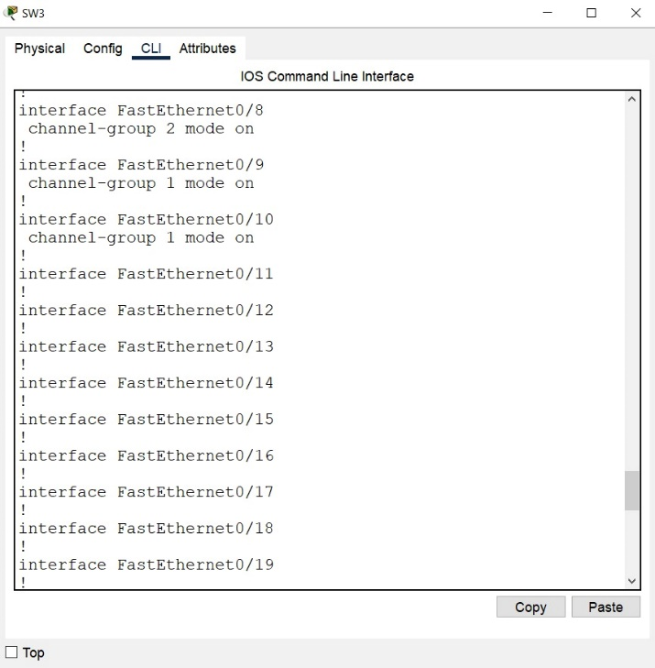 channel-group 1 mode on

interface FastEthernet0/10

channel-group 1 mode on

interface FastEthernet0/11

interface FastEthernet0/12

interface FastEthernet0/13

interface FastEthernet0/14

interface FastEthernet0/15

interface FastEthernet0/16

interface FastEthernet0/17

interface FastEthernet0/18

interface FastEthernet0/19

interface FastEthernet0/20

interface FastEthernet0/21

interface FastEthernet0/22

interface FastEthernet0/23

interface FastEthernet0/24

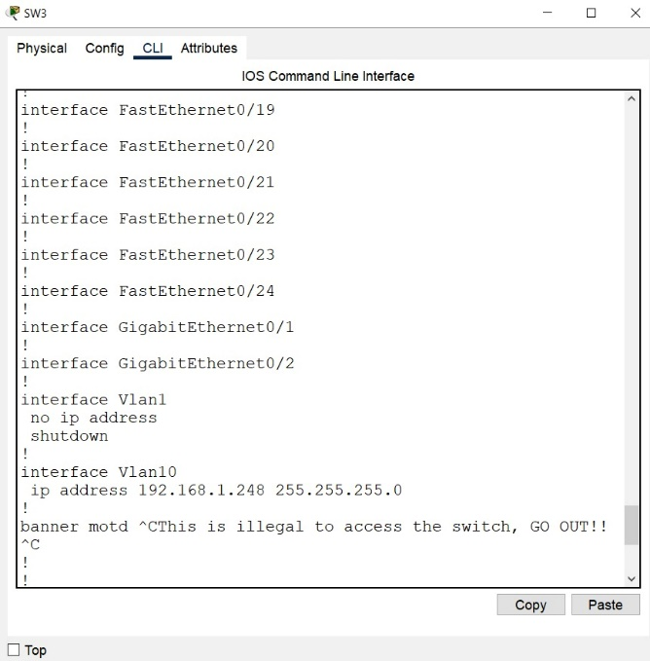interface GigabitEthernet0/1

interface GigabitEthernet0/2

interface Vlan1

no ip address

shutdown

interface Vlan10

ip address 192.168.1.248 255.255.255.0

banner motd "This is illegal to access the switch, GO OUT!!"

line con 0

password 7 08701E1D5D4C53

login

line vty 0 4

password 7 08701E1D5D4C53

login

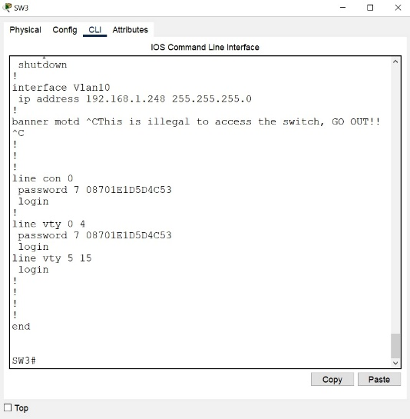line vty 5 15

login

end

-Core-SW Config-Code :

version 12.2(37)SE1

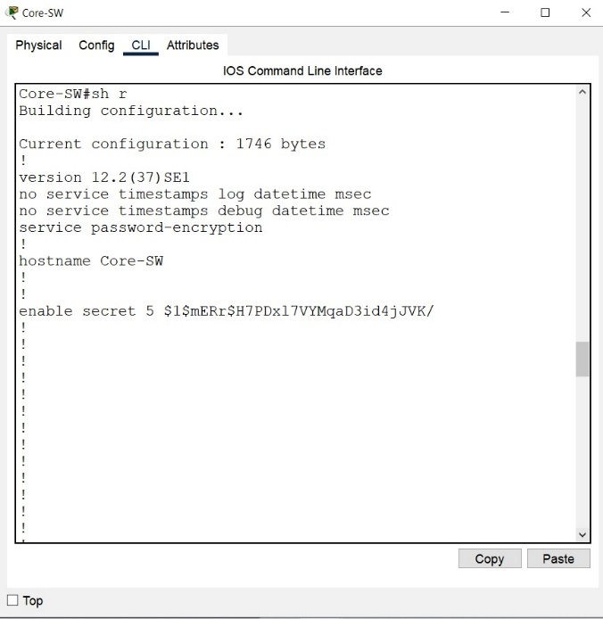no service timestamps log datetime msec

no service timestamps debug datetime msec

service password-encryption

hostname Core-SW

enable secret 5 $1$mERr$H7PDxl7VYMqaD3id4jJVK/

spanning-tree mode pvst

interface FastEthernet0/1

switchport trunk encapsulation dot1q

switchport mode trunk

interface FastEthernet0/2

switchport trunk encapsulation dot1q

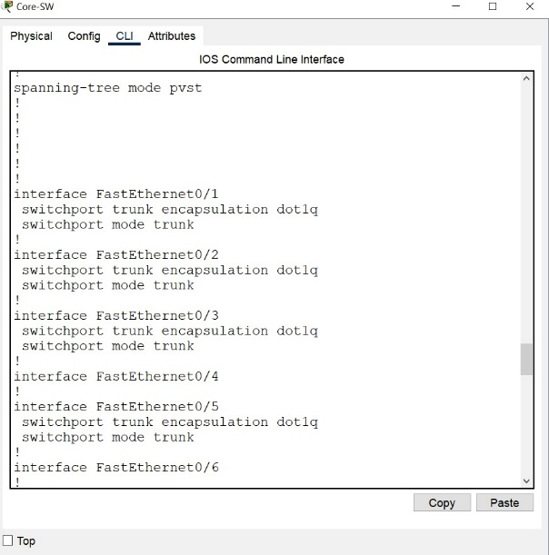 switchport mode trunk

interface FastEthernet0/3

switchport trunk encapsulation dot1q

switchport mode trunk

interface FastEthernet0/4

interface FastEthernet0/5

switchport trunk encapsulation dot1q

switchport mode trunk

interface FastEthernet0/6

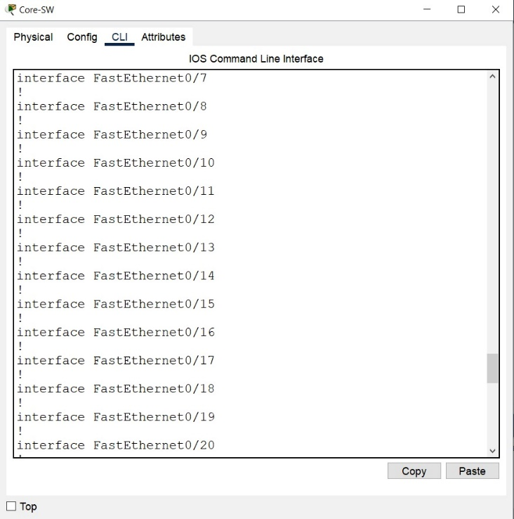interface FastEthernet0/7

interface FastEthernet0/8

interface FastEthernet0/9

interface FastEthernet0/10

interface FastEthernet0/11

interface FastEthernet0/12

interface FastEthernet0/13

interface FastEthernet0/14

interface FastEthernet0/15

interface FastEthernet0/16

interface FastEthernet0/17

interface FastEthernet0/18

interface FastEthernet0/19

interface FastEthernet0/20

interface FastEthernet0/21

interface FastEthernet0/22

interface FastEthernet0/23

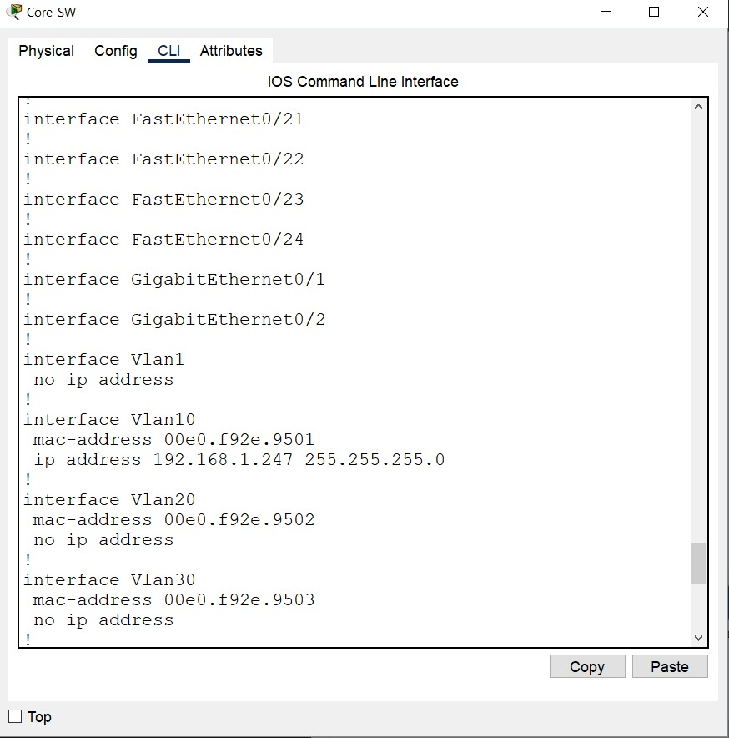interface FastEthernet0/24

interface GigabitEthernet0/1

interface GigabitEthernet0/2

interface Vlan1

no ip address

interface Vlan10

mac-address 00e0.f92e.9501

ip address 192.168.1.247 255.255.255.0

interface Vlan20

mac-address 00e0.f92e.9502

no ip address

interface Vlan30

mac-address 00e0.f92e.9503

no ip address

ip classless

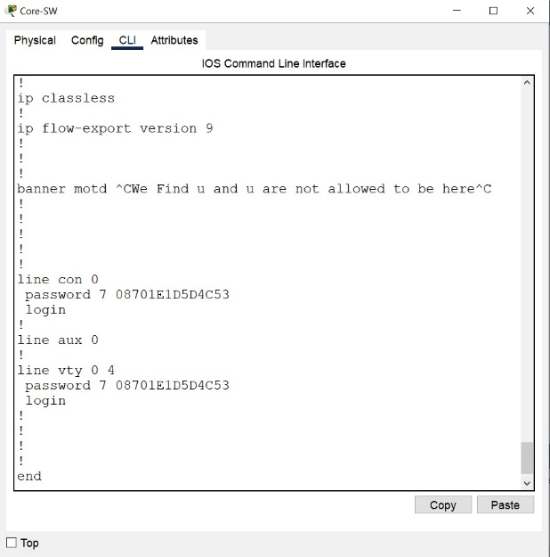ip flow-export version 9

banner motd "We Find u and u are not allowed to be here"

line con 0

password 7 08701E1D5D4C53

login

line aux 0

line vty 0 4

password 7 08701E1D5D4C53

login

end

why we used Router ISR4331 in our project ?

The Cisco ISR4331 is a versatile second-generation Integrated Services Router (ISR) from Cisco's 4000 series. While similar to the ISR4431, it offers slightly lower performance and features.

**Key features include:**

* **High Performance:** The ISR4331 delivers robust packet forwarding and filtering capabilities, making it suitable for medium-sized businesses and enterprise branch offices.
* **Flexibility and Scalability:** Easily customizable with Network Modules (NIMs) and Service Modules (SMs) to add new features and functions.
* **Security:** Offers a comprehensive suite of security features, including firewalls, VPN encryption, and access control.
* **Network Management:** Supports standard network management protocols like SNMP, Telnet, and SSH for easy monitoring and administration.
* **Diverse Applications:** Suitable for a wide range of applications, including
  + Branch offices: Provides secure and reliable connectivity between different branch locations.
  + Small and medium-sized businesses: Delivers a robust network infrastructure.
  + Internet services: Can be used to provide internet services to end-users.

**When to choose the ISR4331:**

* **Budget-constrained projects:** If you're looking for a cost-effective, high-performing ISR, the ISR4331 is a great option.
* **Small and medium-sized networks:** The ISR4331 offers all the essential features for building a reliable and secure network for SMBs.
* **Applications with moderate performance requirements:** If your performance needs are not extremely demanding, the ISR4331 can meet your requirements.

**In summary, the Cisco ISR4331 is a robust and customizable router that offers a wide range of features to meet the needs of medium-sized businesses and enterprise branch offices.**

 - The congifuration code of Router :

Unauthorized access to this device is prohibited!

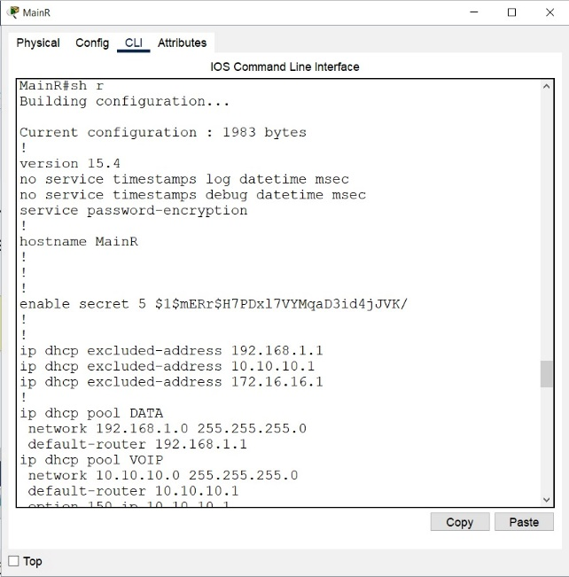MainR>en

Password:

MainR#sh ru

Building configuration...

Current configuration : 1983 bytes

version 15.4

no service timestamps log datetime msec

no service timestamps debug datetime msec

service password-encryption

hostname MainR

enable secret 5 $1$mERr$H7PDxl7VYMqaD3id4jJVK/

ip dhcp excluded-address 192.168.1.1

ip dhcp excluded-address 10.10.10.1

ip dhcp excluded-address 172.16.16.1

ip dhcp pool DATA

network 192.168.1.0 255.255.255.0

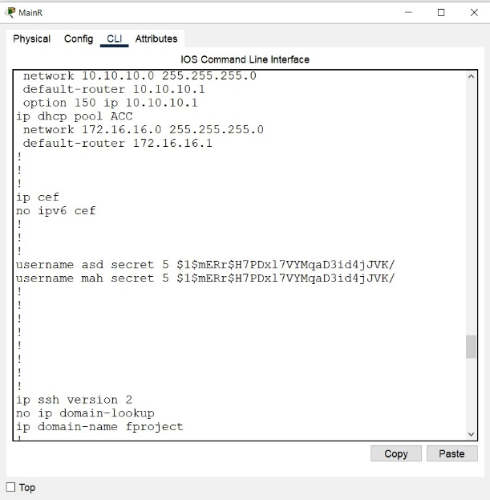 default-router 192.168.1.1

ip dhcp pool VOIP

network 10.10.10.0 255.255.255.0

default-router 10.10.10.1

option 150 ip 10.10.10.1

ip dhcp pool ACC

network 172.16.16.0 255.255.255.0

default-router 172.16.16.1

--More—

%DHCPD-4-PING_CONFLICT:

DHCP address conflict: server pinged 10.10.10.6.

ip cef

no ipv6 cef

username asd secret 5 $1$mERr$H7PDxl7VYMqaD3id4jJVK/

username mah secret 5 $1$mERr$H7PDxl7VYMqaD3id4jJVK/

ip ssh version 2

no ip domain-lookup

ip domain-name fproject

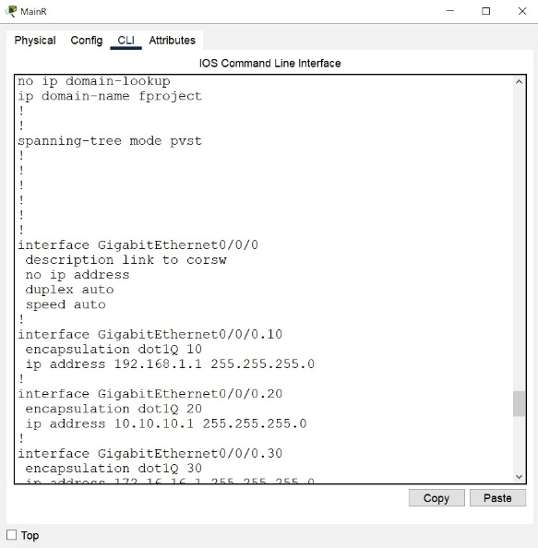spanning-tree mode pvst

--More-- !

interface GigabitEthernet0/0/0

description link to corsw

no ip address

duplex auto

speed auto

interface GigabitEthernet0/0/0.10

encapsulation dot1Q 10

ip address 192.168.1.1 255.255.255.0

interface GigabitEthernet0/0/0.20

encapsulation dot1Q 20

ip address 10.10.10.1 255.255.255.0

interface GigabitEthernet0/0/0.30

encapsulation dot1Q 30

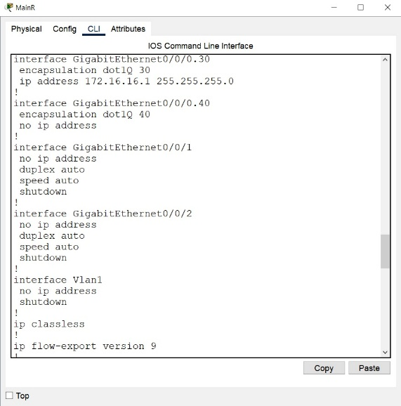 --More-- MainR# ip address 172.16.16.1 255.255.255.0

interface GigabitEthernet0/0/0.40

encapsulation dot1Q 40

no ip address

interface GigabitEthernet0/0/1

no ip address

duplex auto

speed auto

shutdown

interface GigabitEthernet0/0/2

no ip address

duplex auto

speed auto

shutdown

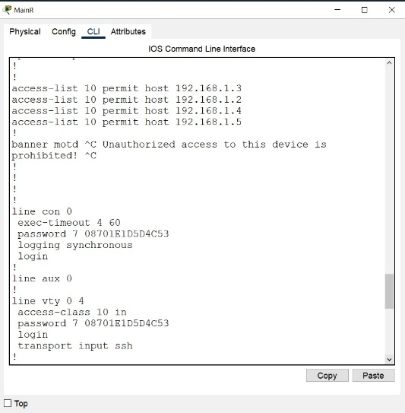interface Vlan1

no ip address

shutdown

ip classless

ip flow-export version 9

access-list 10 permit host 192.168.1.3

access-list 10 permit host 192.168.1.2

access-list 10 permit host 192.168.1.4

access-list 10 permit host 192.168.1.5

banner motd ^C Unauthorized access to this device is prohibited! ^C

line con 0

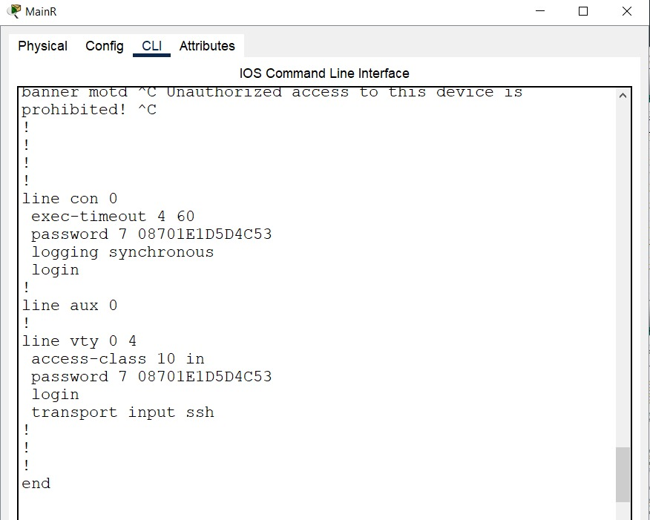 exec-timeout 4 60

password 7 08701E1D5D4C53

logging synchronous

login

line aux 0

line vty 0 4

access-class 10 in

password 7 08701E1D5D4C53

login

transport input ssh

end

* ping device to device :-

Cisco Packet Tracer PC Command Line 1.0

C:\>ssh -l asd 192.168.1.1

Password:

% Password: timeout expired!

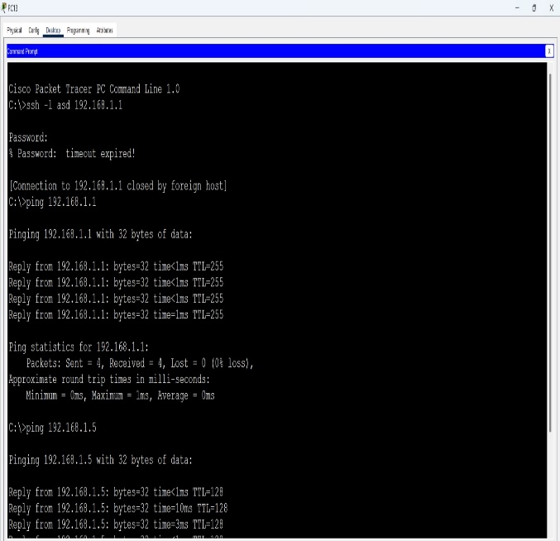

[Connection to 192.168.1.1 closed by foreign host]

C:\>ping 192.168.1.1

Pinging 192.168.1.1 with 32 bytes of data:

Reply from 192.168.1.1: bytes=32 time<1ms TTL=255

Reply from 192.168.1.1: bytes=32 time<1ms TTL=255

Reply from 192.168.1.1: bytes=32 time<1ms TTL=255

Reply from 192.168.1.1: bytes=32 time=1ms TTL=255

Ping statistics for 192.168.1.1:

Packets: Sent = 4, Received = 4, Lost = 0 (0% loss),

Approximate round trip times in milli-seconds:

Minimum = 0ms, Maximum = 1ms, Average = 0ms

C:\>ping 192.168.1.5

Pinging 192.168.1.5 with 32 bytes of data:

Reply from 192.168.1.5: bytes=32 time<1ms TTL=128

Reply from 192.168.1.5: bytes=32 time=10ms TTL=128

Reply from 192.168.1.5: bytes=32 time=3ms TTL=128

Reply from 192.168.1.5: bytes=32 time<1ms TTL=128

Ping statistics for 192.168.1.5:

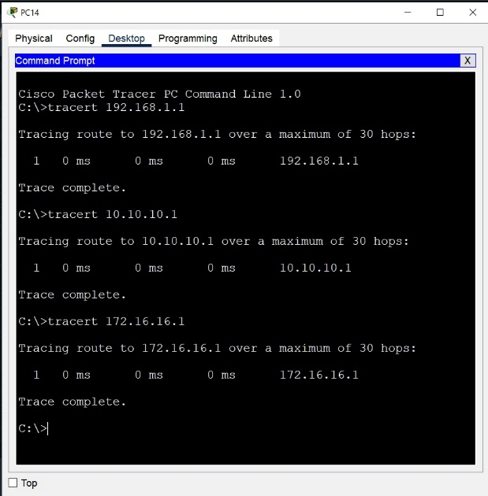 Packets: Sent = 4, Received = 4, Lost = 0 (0% loss),

Approximate round trip times in milli-seconds:

Minimum = 0ms, Maximum = 10ms, Average = 3ms

C:\>

C:\>ping 192.168.1.250

Pinging 192.168.1.250 with 32 bytes of data:

Reply from 192.168.1.250: bytes=32 time<1ms TTL=255

Reply from 192.168.1.250: bytes=32 time<1ms TTL=255

Reply from 192.168.1.250: bytes=32 time<1ms TTL=255

Reply from 192.168.1.250: bytes=32 time<1ms TTL=255

Ping statistics for 192.168.1.250:

Packets: Sent = 4, Received = 4, Lost = 0 (0% loss),

Approximate round trip times in milli-seconds:

Minimum = 0ms, Maximum = 0ms, Average = 0ms

C:\>ping 192.168.1.249

Pinging 192.168.1.249 with 32 bytes of data:

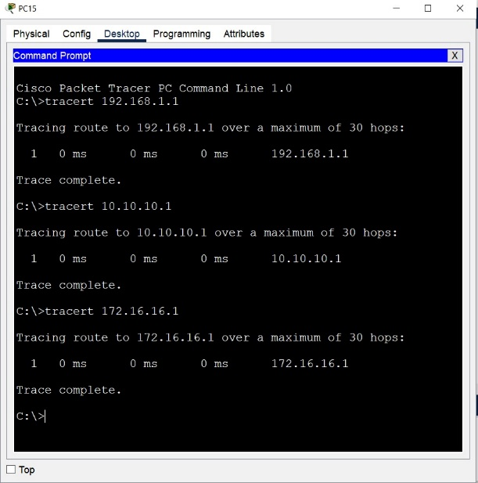Request timed out.

Reply from 192.168.1.249: bytes=32 time<1ms TTL=255

Reply from 192.168.1.249: bytes=32 time=1ms TTL=255

Reply from 192.168.1.249: bytes=32 time<1ms TTL=255

Ping statistics for 192.168.1.249:

Packets: Sent = 4, Received = 3, Lost = 1 (25% loss),

Approximate round trip times in milli-seconds:

Minimum = 0ms, Maximum = 1ms, Average = 0ms

C:\>ping 172.16.16.4

Pinging 172.16.16.4 with 32 bytes of data:

Reply from 172.16.16.4: bytes=32 time=1ms TTL=127

Reply from 172.16.16.4: bytes=32 time<1ms TTL=127

Reply from 172.16.16.4: bytes=32 time<1ms TTL=127

Reply from 172.16.16.4: bytes=32 time<1ms TTL=127

Ping statistics for 172.16.16.4:

Packets: Sent = 4, Received = 4, Lost = 0 (0% loss),

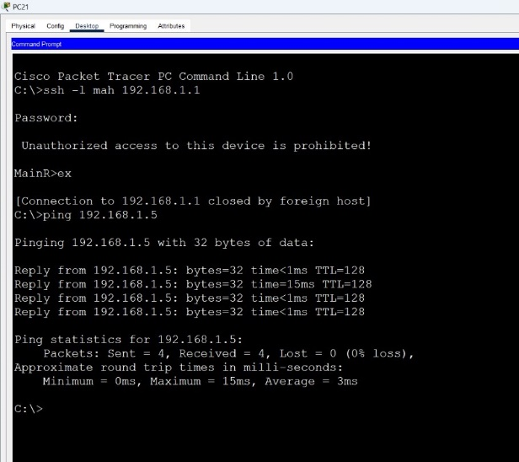Approximate round trip times in milli-seconds:

Minimum = 0ms, Maximum = 1ms, Average = 0ms

C:\>ping 192.168.1.247

Pinging 192.168.1.247 with 32 bytes of data:

Reply from 192.168.1.247: bytes=32 time<1ms TTL=255

Reply from 192.168.1.247: bytes=32 time<1ms TTL=255

Reply from 192.168.1.247: bytes=32 time<1ms TTL=255

Reply from 192.168.1.247: bytes=32 time<1ms TTL=255

Ping statistics for 192.168.1.247:

Packets: Sent = 4, Received = 4, Lost = 0 (0% loss),

Approximate round trip times in milli-seconds:

Minimum = 0ms, Maximum = 0ms, Average = 0ms

C:\>ping 10.10.10.3

Pinging 10.10.10.3 with 32 bytes of data:

Request timed out.

Reply from 10.10.10.3: bytes=32 time=1ms TTL=254

Reply from 10.10.10.3: bytes=32 time<1ms TTL=254

Reply from 10.10.10.3: bytes=32 time<1ms TTL=254

Ping statistics for 10.10.10.3:

Packets: Sent = 4, Received = 3, Lost = 1 (25% loss),

Approximate round trip times in milli-seconds:

Minimum = 0ms, Maximum = 1ms, Average = 0ms

C:\>

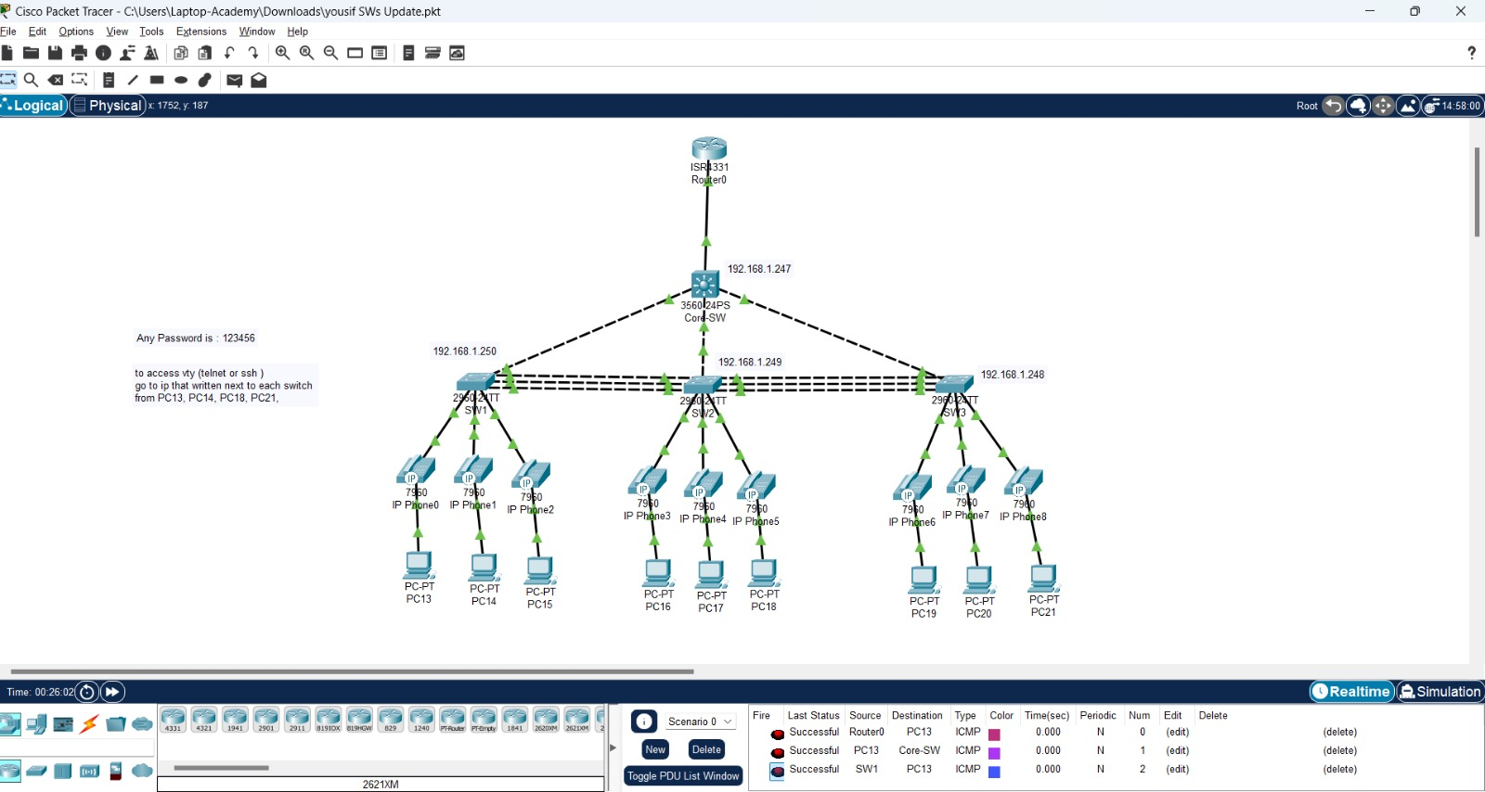

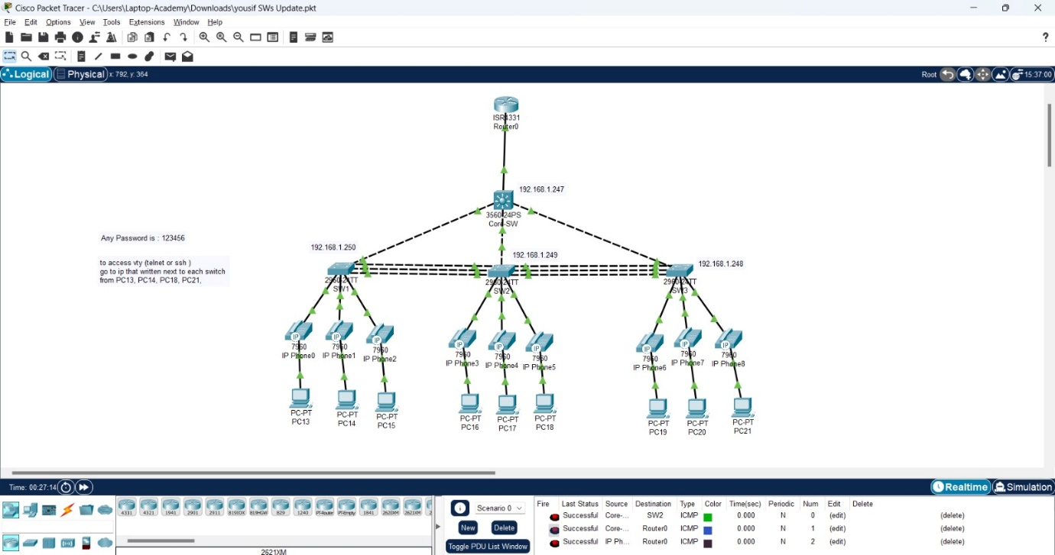

why we used IP Phone 7960 in our project ?

The Cisco IP Phone 7960 is a Voice over Internet Protocol (VoIP) phone developed by Cisco. While it's considered a bit older, it's still widely used in many businesses and organizations.

**Key features of the Cisco IP Phone 7960:**

* **Traditional design:** It has a classic design that resembles traditional landline phones, making it easy for employees to use.
* **High-quality audio:** Delivers clear and excellent audio quality for voice calls.
* **Multiple features:** Supports a wide range of features, such as:
  + Conference calls
  + Call transfer
  + Music on hold
  + Call history
  + User directory
* **Easy management:** Can be easily managed through Cisco CallManager.
* **Expandable:** Can be expanded with additional modules.

**Uses of the Cisco IP Phone 7960:**

This phone is primarily used in:

* **Businesses:** To provide voice communications for employees both inside and outside the company.
* **Organizations:** In hospitals, schools, and universities to provide internal and external communications.
* **Hotels:** To provide communication services for guests.

**Why choose the Cisco IP Phone 7960?**

* **Reliability:** It is highly reliable and offers excellent performance.
* **Ease of use:** Intuitive and user-friendly interface.
* **Integration with other Cisco systems:** Can be easily integrated with other Cisco systems.
* **Long-term support:** Offers long-term support from Cisco.

**Drawbacks of the Cisco IP Phone 7960:**

* **Outdated design:** Compared to modern phones, its design may seem outdated.
* **Limited features:** May not have all the features available in modern phones.
* **End-of-life:** Support for this phone may be discontinued in the near future.

**If you're looking for a reliable and affordable VoIP phone, the Cisco IP Phone 7960 is a good option. However, if you're looking for the latest features and technology, you may need to consider other more modern options.**

**Do you have any other questions about the Cisco IP Phone 7960?**

**I can help you with:**

* **Comparing this phone to other VoIP phones**
* **Poviding information on specific technical features**

Any questions

Thankyou